Name: Tahir Naranjee
ABC Retail

A. Create an Azure SQL database
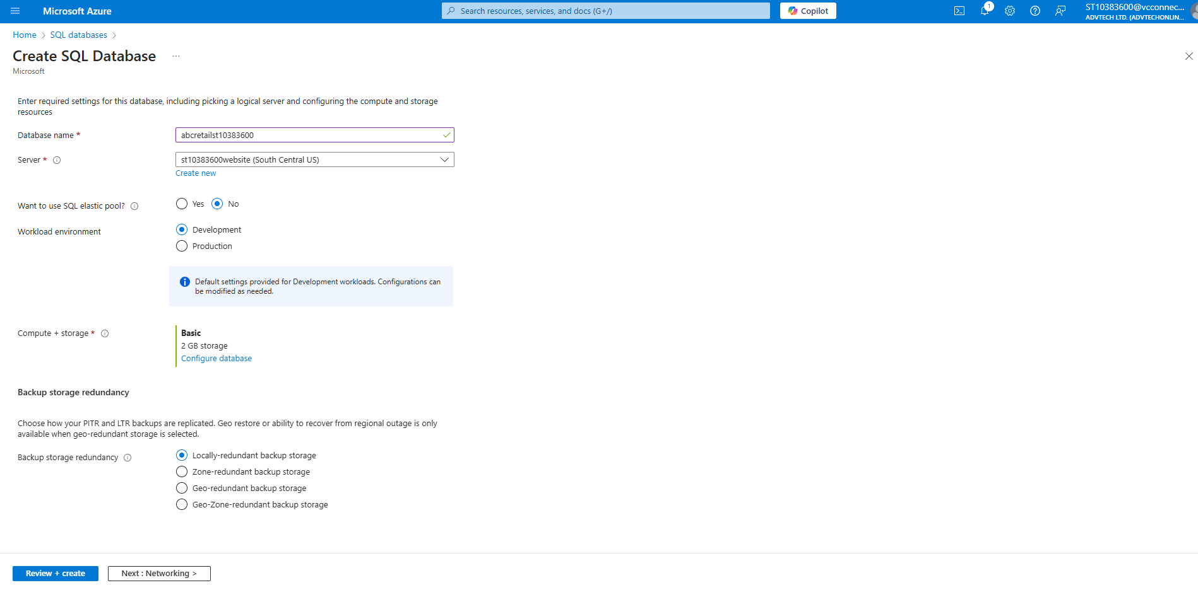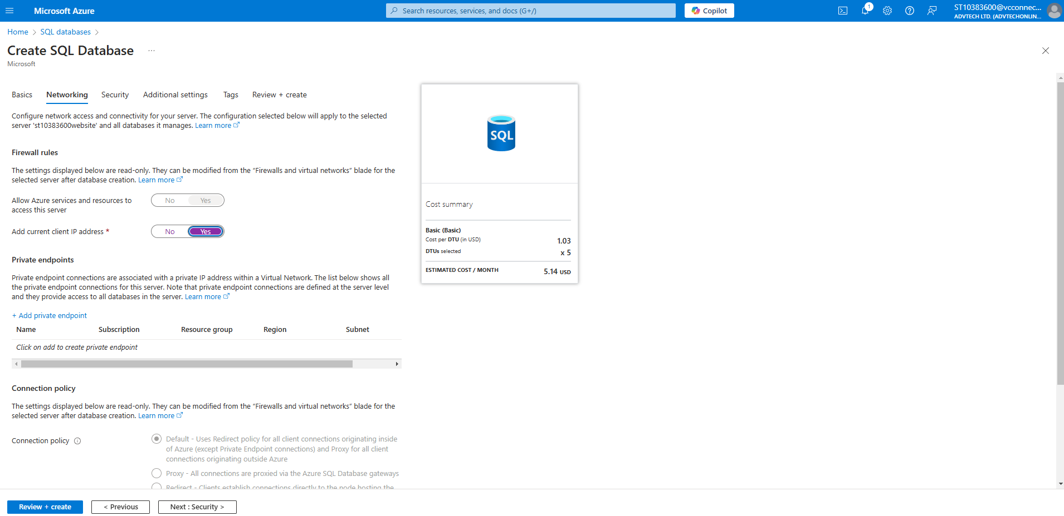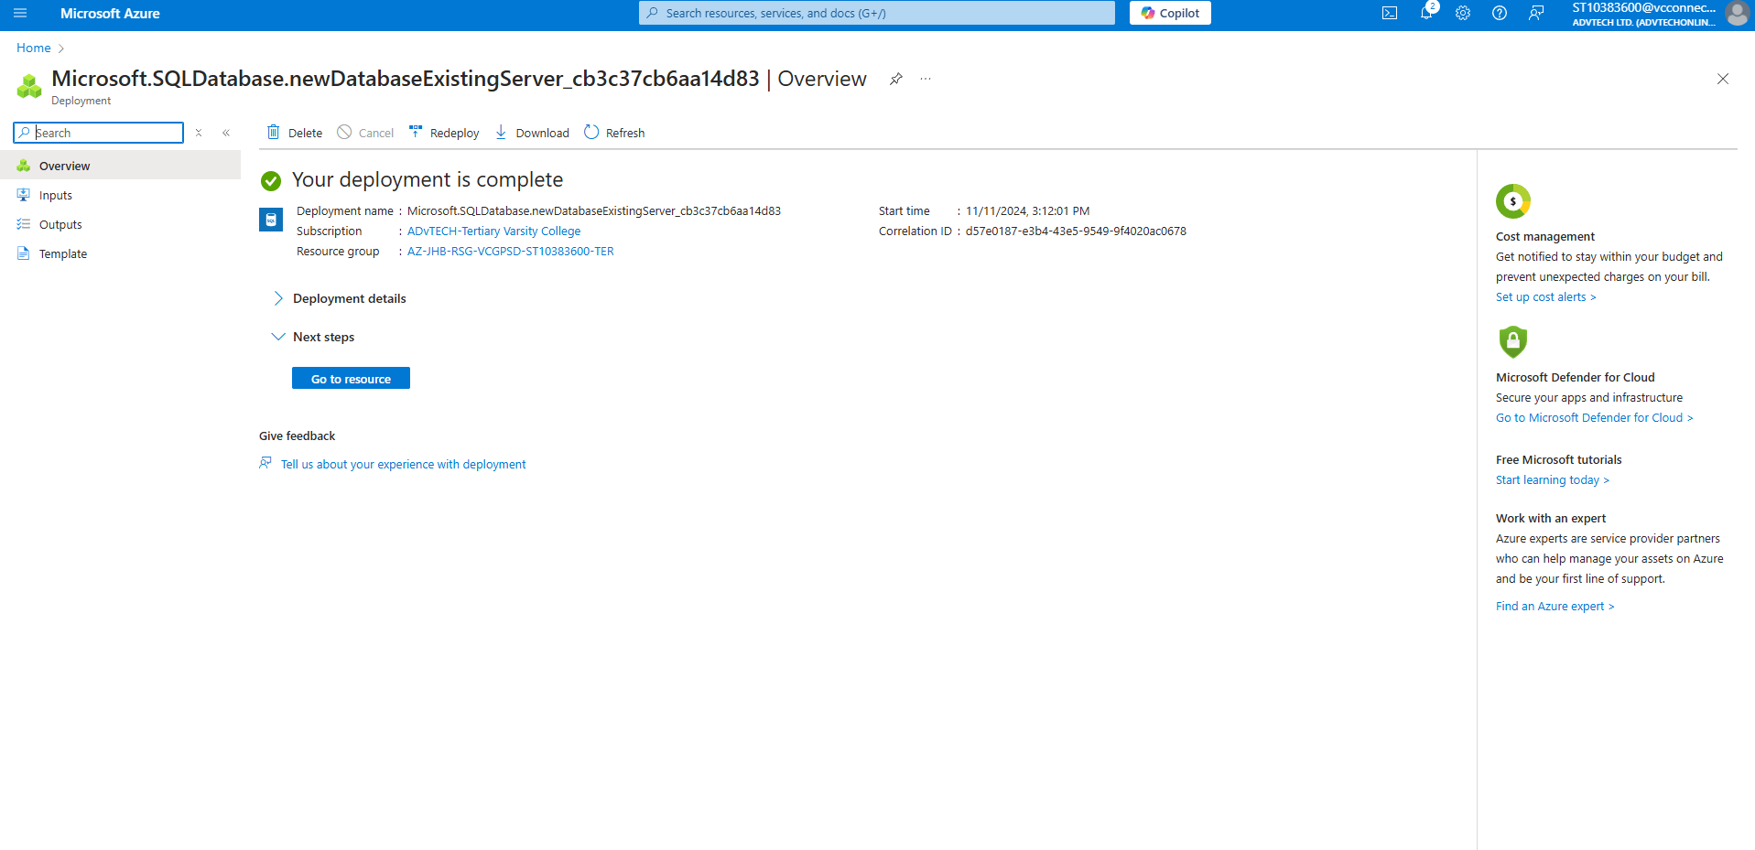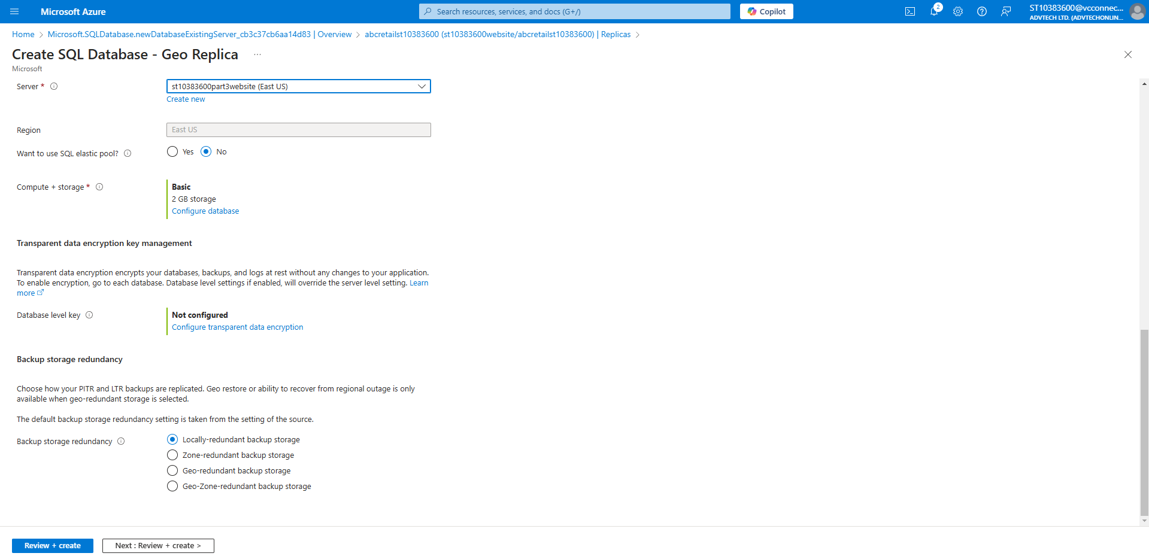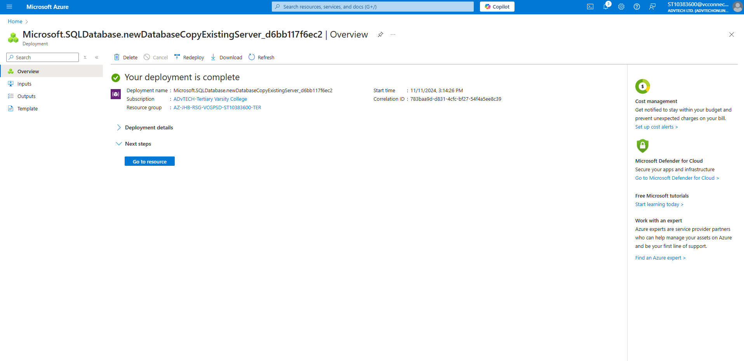
(GeeksforGeeks, 2022)
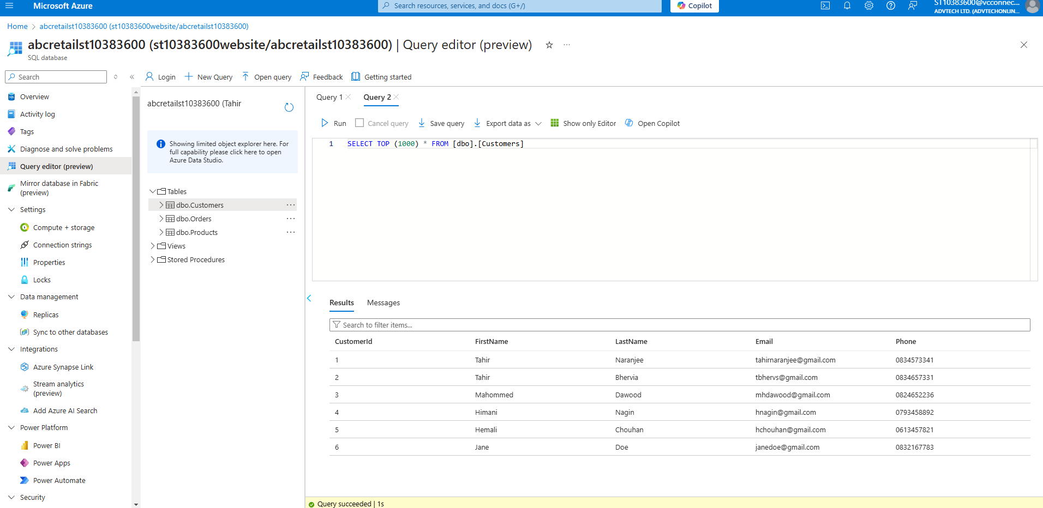

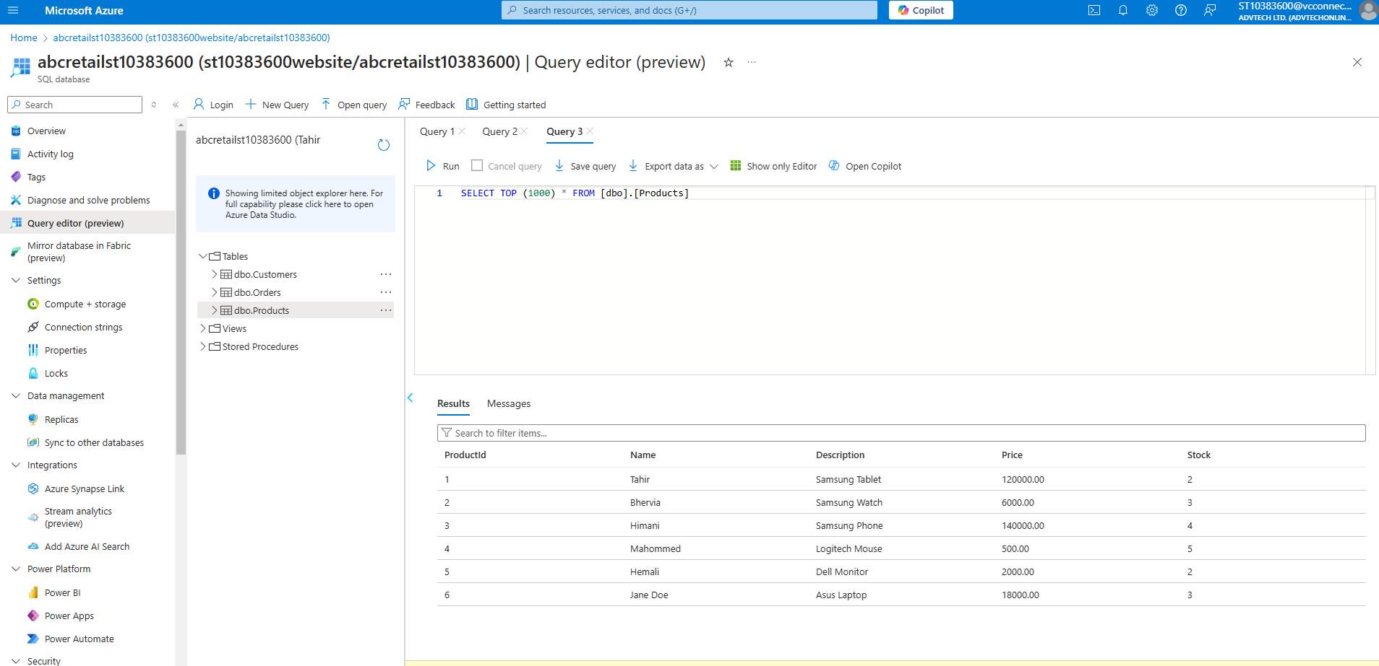

B. Technology Choices Documentation
The solution incorporates several Azure services, each carefully selected to meet the project’s goals of security, scalability, and efficiency. Consider the outline below of the main Azure components, the rationale behind choosing each technology, and the hosting models used.
- Component: Azure SQL Database:
  - Technology Choice: This is a fully managed cloud database designed for handling structured data such as customer, product, and order information.
  - Hosting Model: As a PaaS (Platform-as-a-Service), Azure SQL Database automates routine tasks like backups and scaling, allowing for a secure, adaptable data storage solution that can support application growth.
- Component: Azure App Service:
  - Technology Choice: Azure App Service provides a streamlined environment for deploying and managing web applications. It hosts the MVC app, facilitating deployment, automatic scaling, and load balancing without manual configuration.
  - Hosting Model: This PaaS service makes it easy to integrate CI/CD, ensuring that the application can handle varying traffic demands.
- Component: Azure Key Vault:
  - Technology Choice: This service manages sensitive information such as API keys and database credentials securely, helping reduce risks by storing secrets centrally and restricting access to authorised users only.
  - Hosting Model: Key Vault, as a PaaS, safeguards application secrets and ensures sensitive data is accessible only when necessary.
- Component: Azure Application Insights:
  - Technology Choice: Application Insights provides monitoring and diagnostic capabilities in real-time, which helps track the app’s performance and pinpoint issues.
  - Hosting Model: This PaaS service is tightly integrated with the application to help analyse usage patterns, optimise performance, and identify areas for improvement.

- Component: Azure Storage Account:
  - Technology Choice: Used to store static files (e.g., images, JavaScript files), the Azure Storage Account offers reliable and durable storage with quick access. This PaaS component supports fast retrieval of assets essential for a smooth user experience.
- Component: Azure Load Balancer:
  - Technology Choice: This service distributes incoming traffic across multiple application instances, ensuring high availability and reliability.
  - Hosting Model: As an IaaS (Infrastructure-as-a-Service) solution, it improves the app’s resilience during high traffic, providing a consistent experience to users. (K. Mrzyglod, 2022)

C. Justification for the Azure Services Selected
Each Azure service was selected to meet specific application requirements, providing tailored functionality and performance.
Here is why each service was chosen to satisfy this project’s needs:
- Azure SQL Database:
  - Requirement: Reliable, secure storage for structured data.
  - Justification: Azure SQL Database is designed for structured data storage, supporting automated backups, seamless scalability, and advanced security. It meets the need for a secure, managed environment that can handle sensitive customer and product data.
- Azure App Service:
  - Requirement: Hosting for the MVC web application.
  - Justification: App Service offers a simplified environment for deploying and managing the web app, providing automatic scaling, load balancing, and deployment support. This makes it ideal for creating a responsive, high-availability environment that can adjust to traffic demands.
- Azure Key Vault:
  - Requirement: Secure storage for application secrets.
  - Justification: Azure Key Vault offers centralised storage for sensitive data, like API keys and connection strings, helping minimise exposure risks. By controlling access to these secrets, it enhances application security.
- Azure Application Insights:
  - Requirement: Performance tracking and diagnostic capabilities.
  - Justification: Application Insights enables real-time tracking of app performance, offering insight into user interactions and system bottlenecks. This helps maintain an optimal user experience and troubleshoot potential issues effectively.
- Azure Storage Account:
  - Requirement: Scalable storage for static content.
  - Justification: Azure Storage Account provides a stable and highly accessible environment for storing static files. It supports the fast delivery of assets, which improves front-end performance and accessibility.
- Azure Load Balancer:
  - Requirement: Efficient traffic distribution.
  - Justification: Azure Load Balancer helps distribute traffic evenly across instances, increasing the app’s availability and stability under heavy traffic. This improves the user experience by ensuring that servers remain available even during peak times.
These services collectively enable the application to function as a secure, scalable, and reliable system tailored to its requirements. (K. Mrzyglod, 2022)

D. Alternative Azure Technologies
Although the chosen services work well for the solution, other Azure options could be considered.
Some alternative technologies that could also meet the application requirements effectively are as follows:
- Alternative to Azure SQL Database: Azure Cosmos DB:
  - Requirement: Scalable, distributed data storage.
  - Alternative: Azure Cosmos DB offers globally distributed data storage with low latency, making it a solid option for scenarios needing high availability across multiple regions. It’s suitable for applications requiring scalable, high-speed data operations.
- Alternative to Azure App Service: Azure Kubernetes Service (AKS):
  - Requirement: Hosting and scaling the web application.
  - Alternative: AKS allows for containerised deployments and offers fine-grained control over scaling and resources. For applications that could benefit from a microservices approach or need more control over deployment, AKS is a powerful choice.
- Alternative to Azure Key Vault: Azure Managed HSM:
  - Requirement: Advanced security for sensitive data.
  - Alternative: Azure Managed Hardware Security Module (HSM) provides encryption at a hardware level, making it ideal for applications with strict regulatory requirements. It’s a secure option for highly sensitive data and scenarios where hardware-backed security is preferred.
- Alternative to Azure Application Insights: Azure Monitor:
  - Requirement: Comprehensive application monitoring.
  - Alternative: Azure Monitor offers a wider range of monitoring capabilities across applications, infrastructure, and networks, making it ideal for solutions requiring extensive oversight. It provides a centralised monitoring experience that could be beneficial for larger-scale applications. (K. Mrzyglod, 2022)

References
K. Mrzyglod, R. C. (2022). Azure for Developers. Packt Publishing.
GeeksforGeeks (2022). Microsoft Azure Azure SQL Database Deployment Options. [online] GeeksforGeeks. Available at: https://www.geeksforgeeks.org/microsoft-azure-azure-sql-database-deployment-options/ [Accessed 12 Nov. 2024].
WilliamDAssafMSFT (2024). Create a single database - Azure SQL Database. [online] Microsoft.com. Available at: https://learn.microsoft.com/en-us/azure/azure-sql/database/single-database-create-quickstart?view=azuresql&tabs=azure-portal [Accessed 12 Nov. 2024].

